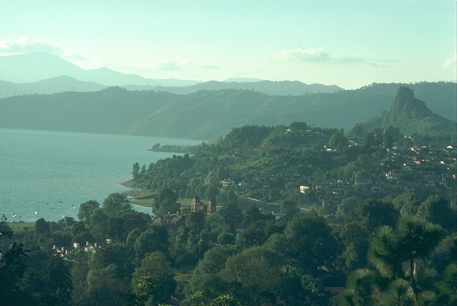
Valle de Bravo
Mexico's Valle de Bravo (the "Fierce Valley") is located in the Sierra Madre del Sur, a mountain range south of Mexico City. It is a popular recreational destination for residents of the heavily populated and polluted Mexico City. The Sierra Madre del Sur is one of the three ranges that make up the Sierra Madre Mountains -- the dominant physical feature of Mexico. While Mexico's mountains -- like the Andes in various South American countries -- often promote tourism, such rugged topography also poses challenges for economic development and national integration.
Using the image and your knowledge of geography, answer the following questions:

ART: Question 1
What are the two major mountain chains in Latin America?
Question 2
Using a map of Mexico, indicate where the Sierra Madre del Sur is located.
Question 3
What types of obstacles can a mountainous geography have on human development?

