The Berlin Wall
The collapse of Communism in the Soviet Union and Eastern Europe changed the political geography of the region once again. No image more powerfully represents the end of the Cold War than that of the Berlin Wall in Germany. The wall was built right through the city in 1961 in order to prevent the population of the eastern part of the divided city and country from fleeing to the West. The huge, reinforced-concrete barrier, topped with barbed wire had open zones on the eastern side, making it difficult to approach without being seen, and was patrolled day and night -- people who attempted to cross without the proper authorization were shot. This image is a view through a hole in the Berlin Wall, looking from West Berlin to East Berlin. Visible in the distance is the Fernsehturm (television tower) which stands in Alexanderplatz, in the neighborhood of Mitte, East Berlin. Both East and West Berlin were rebuilt from the rubble after World War II. However, the different governments had distinctly different impacts on the architectural styles of their cities. East Berlin, as you can see from the picture, was rebuilt in largely the same traditional style as the pre-war city. West Berlin had more examples of modern architecture and infrastructure.
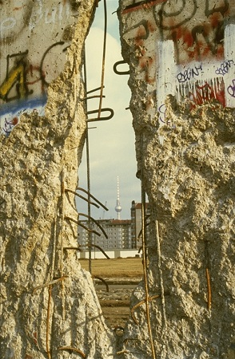

Using the image and your knowledge of geography, answer the following questions:
Question 1:
After looking at the image, how effective of a barrier do you think this wall was to the movement of people and goods? How effective do you think it was in relation to the movement of ideas?

Question 2:
What about the political situation had to change before the Berlin Wall could be destroyed?

