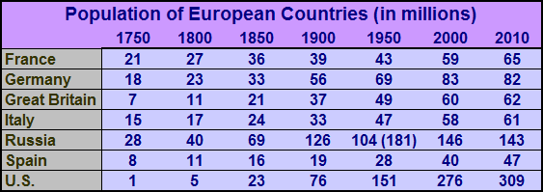
Population of Europe
The chart shows the changes in the populations of six European countries and the United States between 1750 and 2010. These population statistics must be considered with a note of caution since most countries did not take a census before the 19th century. (The United States was among the first to require a periodic census by law.) Also, population figures during the 19th century were often based on inaccurate and incomplete methods of counting the population. Furthermore, in trying to draw conclusions about population figures in one country over time, or in comparing changes among nations, note that the raw data does not include changes in national boundaries, except in the case of Russia in 1991. The population of the United States grew between 1750 and 1850 not only because of immigration and the birth of children, but also because the Louisiana Territory was added in 1803 and the Mexican territory in 1848. The Russian Empire expanded into Central Asia and Eastern Europe between 1750 and 1900. Germany and Italy were clusters of separate principalities, some of which were under the control of other nations until later in the 19th century. Nevertheless, it remains possible to draw some conclusions from these statistics. A starting point in comparing population change is to look at the growth of the United States in relation to Europe. In 1750, there were 69 West Europeans (the six nations listed on the chart minus Russia) for every American living in the thirteen colonies. By 1900, there were 184 West Europeans for every 76 Americans, or a ratio of about 2.5 to 1 instead of 69 to 1. By 2000 the population of the United States (276 million) was only slightly less than that of Western Europe (300 million). The phenomenal growth of the United States can be attributed to immigration, higher birth rates, and territorial expansion. France had the most powerful military in Europe in 1750 and 1800, though Britain had the strongest navy. France's strength rested largely on the fact that it had more people than any other nation except Russia, which was not considered part of Europe at the time. However, France's population did not grow as rapidly as Great Britain's and Germany's. Between 1750 and 1900, Great Britain's population increased more than five times and Germany's more than tripled, but France's did not even double. Europe's population in general increased sharply during the 19th century, in part because of the Industrial Revolution, which had its greatest impact in Great Britain and Germany. Population can also be viewed as a factor in determining relative importance in the world. In 1900, one-fourth of the world's population were Europeans (including Russia). By 2000, Europeans were only 14% of the world's population. Europe, because of its advanced economy, is more powerful than its proportion of the world population would suggest. However, world population trends suggest that Europe will become an even smaller percent of the world's population and decline in relative importance.
Using the chart and your knowledge of European geography, answer the following questions:

WorldView Software: World Geography
GRAPH: Question 1
Which nation in Europe showed the largest increase in population between 1900 and 2000? Why is the population of Russia in 1950 shown with two population figures?

Question 2
Why should these population figures be viewed with caution? Despite these cautions, why can they still be used to draw conclusions and comparisons about population changes?

Question 3
Why did the populations of some countries in Europe grow more rapidly than others between 1800 and 1900?

