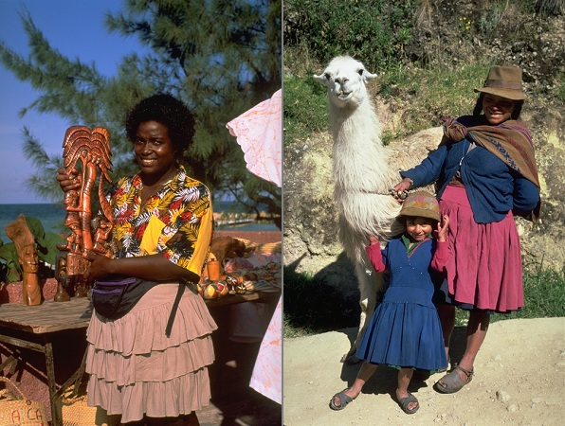
People of Jamaica/Peru
As in many of the Caribbean nations, Jamaica's population is primarily (90%) of African origin. Those with both African and European (mainly British) or Asian roots make up another 9%. Jamaica's popular culture is a unique mix of English, African, and Latin American traditions. While their political institutions and forms of expression are based on British traditions, many cultural traditions such as handicrafts and music draw upon African forms. Reggae music, for example, integrates African, Latin, and European musical styles. This music is also famous for promoting social justice and national identity, expressing the plight of the Jamaican poor alongside the religious ideals of Rastafarianism. Peru's largest ethnic group is indigenous people (45%), followed by mestizos -- people of mixed Spanish and Amerindian ancestry -- (37%), and whites (15%). Although they have experienced centuries of racism, Peru's Amerindian people have proud and independent cultural traditions. The music, arts and crafts, and textiles of Peru's highland peoples have gained international prominence in recent years. Andean music is distinguished by its use of the wooden pan flute and small guitar. Peruvian tapestries and clothing are typically made with llama (pictured here) and alpaca wool. Colorful and richly designed, these works often express Andean religious and storytelling traditions.
Using the image and your knowledge of history and geography, answer the following questions:
WorldView Software: World Geography
ART: Question 1
What are the characteristics of reggae music?
Question 2
What part of Jamaica's history explains why its population is overwhelmingly black?
Question 3
What similarities do you see between African and Andean popular culture in Latin America?

