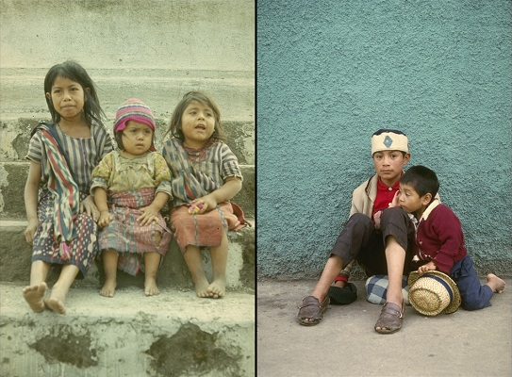
People of Guatemala
About 56% of the Guatemalan population is mestizo (descendants of both European and Amerindian ancestry). Over 40% of the population is indigenous (mainly Mayan). Although indigenous peoples have faced exploitation and mistreatment for centuries, they have maintained a strong tradition of resistance to outside domination. The genocide that began during the Spanish Conquest returned in parts of highland Guatemala during the 1980s, where paramilitary death squads targeted Amerindian communities suspected of supporting subversion. In spite of this, indigenous groups continue to maintain their linguistic, cultural, and religious traditions. Guatemala's Mayan Indians are one of the proudest and most strongly independent ethnic groups in the Americas. Amerindian leader Rigoberta Menchu has been a vocal force in uncovering human rights abuses during the civil war.
Using the image and your knowledge of history and geography, answer the following questions:

WorldView Software: World Geography
ART: Question 1
What is the main indigenous group in Guatemala?
Question 2
Which of the two images suggests the continuation of cultural traditions among the Mayan peoples? Why?
Question 3
What is the main difference between the genocide during the Spanish Conquest and the genocide of the Civil War that took place in the 1980s?

