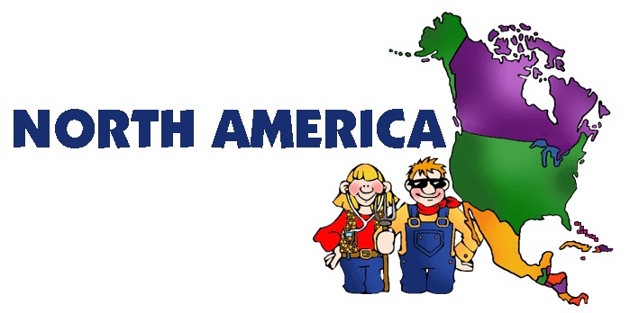

## Your test is now in your hands. Imagine you are in a restaurant and you are choosing your meal. Below describes what you can “order” for your test grade. Choose wisely and aim high! (100 Point Maximum - but you can do more to ensure the highest grade possible)

Canada PowerPoint 4 *(up to 48 points)*

Describe your journey across the 6 Physiographic regions of Canada. You will get 2 points for each good sentence you write for each of the 6 major regions (**maximum of 8 points per region**). Additional research on the areas will help you get full points.

United States PowerPoint 1 *(up to 40 points)*

Explain why each of the 4 reasons why the United States is so wealthy. Each reason should be 3-5 sentences in length (**2 pts. per sentence with a maximum of 10 points for each reason**). Additional research on the areas will help you get full points.

United States PowerPoint 2 *(up to 10 points)*

Describe a trip around the exterior of North America. You will get 1 point for each correct major body of water that you write about (**maximum 10 points**). Illustrating (pictures) your story will get you more points. Additional research on the areas will help you get full points.

Glaciers PowerPoint 2 *(up to 10 points)*

You will need to describe/draw/write a story about glaciers moving over North America. Be creative in the method that you choose (**maximum 10 points**). Additional research on the areas will help you get full points.

Mountain Comparisons PowerPoint 2 *(up to 10 points)*

Compare (same)/Contrast (different) the Rocky Mountains and the Appalachian Mountains. You can write it out or use a Venn diagram. Additional research on the areas will help you get full points. (**Maximum 10 points**)

United States Features PowerPoint 3 *(up to 10 points)*

Use the following terms in a drawing, story/poem, or write out the description. You will get 1 point for each term used (**maximum of 10 points**).

Hawaiian Archipelago Sun Belt Canadian Shield

Aleutian Islands Rust Belt

Grand Canyon Wheat Belt

Continental Divide Great Plains

Corn Belt Atlantic & Gulf Coastal Plains

**COMPLETE SENTENCES ARE MANDATORY ON THE TEST**

Complete

# Test Menu