North America Study Guide Name:____________________ Pd: __
4 Reasons why the United States is so wealthy: (PPT1)

- Tell about Mount McKinley (PPT2)

- Describe the major differences between the Appalachian and Rocky Mountains (PPT2)
- What are the 4 water boundaries of North America (PPT2)
- How did transportation and communications help strengthen our nation’s economy? (PPT1)
- Know what did Samuel Morse invented (PPT1)
- Describe the Great Plains (PPT2)
- Why is the Mississippi River such an important river? (PPT2)
- What makes up the boundary between the United States and Canada (PPT2)
- What is the Canadian Shield (PPT2)
- How did Glaciers affect North America (PPT2)
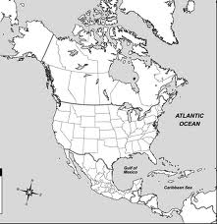
On the map above, draw and label the following regions: (PPT3)

  - Continental divide
  - Corn belt
  - Wheat belt
  - Rust belt
  - Sun belt
  - Great plains
  - Atlantic Coastal Plain
  - Gulf Coastal plains
  - Mississippi river

