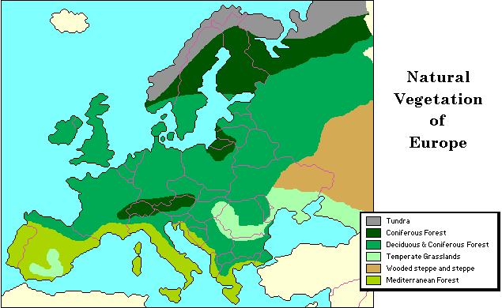
Natural Vegetation of Europe
This map shows the natural vegetation of Europe. Natural vegetation is the type of plants that would grow without the presence of human beings. Although some of the natural vegetation remains, much of it is gone, as human beings killed the plants to grow crops, construct homes and factories, and build roads. By looking at the map we can see that deciduous and coniferous forests are the predominant types of vegetation. The mild and moist climate of much of Europe supports the growth of these trees. Where temperatures are colder, as in the northern latitudes and the higher altitudes, coniferous forests dominate. Where temperatures are even colder, as in the very highest latitudes, and trees cannot grow, tundra vegetation dominates. The vegetation in Southern Europe, called Mediterranean forest, has adapted to the natural dry summers. The eastern part of Europe, extending into Russia, with its drier climate, cannot support forests. Therefore, temperate grasslands, including tall-grassland Prairies or Steppes, predominate. The map reader should keep in mind that although the map shows distinct boundaries from one type of vegetation region to another, the change is not actually so sharp. In real life, the vegetation gradually changes from one type of vegetation to another. The border between forest and grassland does not have only trees on one side and grasslands on the other. Rather the proportion of trees gets smaller as do the trees themselves until grasses are the sole type of vegetation.
Using the map and your knowledge of Geography, answer the following questions:

- What does this map show us?

- What are the major types of natural vegetation found on this map?

- What affects the types of natural vegetation found in this region?

- Which form of natural vegetation takes up the largest portion of Europe?

