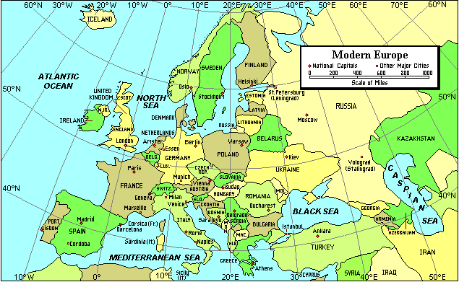
Modern Europe
This map shows political boundaries, national capitals, and major cities of Europe. The symbol for the national capitals is a diamond and for the major cities it is a square. The map contains a scale of miles so that we can measure distances. The map shows that Europe consists of more than 40 countries. The Atlantic Ocean is the western border and, with its arm, the North Sea, the northern border. The Mediterranean Sea is to the south. To the east is Russia and countries which are part of the Commonwealth of Independent States. Many people consider western Russia to be part of Europe so its presence on this map is useful. The map shows that Europe has a wide longitudinal extent. It ranges from western Iceland at about 23 degrees West running past the Prime Meridian at 0 degrees to the Ural Mountains in Russia, at about 60 degrees East. Europe also stretches across a large latitude. Its southern border, along southern parts of Spain, Sicily, and Turkey, is about 35 degrees North. The mainland of Europe has its northern border about 70 degrees North, but a number of islands are located at higher latitudes in the Arctic Ocean. The map shows two significant inland bodies of water. The Caspian Sea, the largest lake in the world, is considered to be part of the eastern border of Europe. The Black Sea separates southeastern Europe and southwest Asia. Both seas are important economically. Yet both have been subject to serious environmental damage. Location near a large body of water is important to development. Countries which border the oceans and seas have greater access to the rest of the world. Countries which do not are called landlocked and they are dependent on their neighbors for transportation to other places.
Using the map and your knowledge of Geography, answer the following questions:

WorldView Software: World Geography
MAP: Question 1
What features of Europe does this map illustrate?
Question 2
Why are mountains and rivers not shown on this map?
Question 3
What is the longitudinal and latitudinal range of Europe?
Question 4
What is the capital of France? Bosnia? Romania?
Question 5
What countries are landlocked? Why is this a disadvantage?
Question 6
What countries and physical features form the eastern border of Europe?

