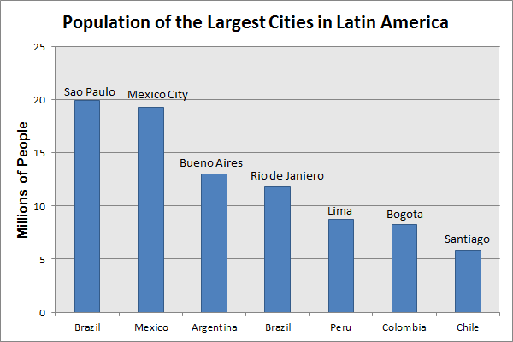
Latin America: Population of Largest Cities
This bar graph illustrates the current population of the 7 largest cities in Latin America. The trend towards urbanization since 1950 has increased the number and size of large cities. The number of Latin American cities with a population over 1 million people rose from 6 in 1950, to 18 in 1970, to over 65 today. In some countries, one city emerged as a "mega-city," with a population explosion beyond the wildest imagination of urban planners. These cities, often the capital city, are usually the nation's center for political, economic, and cultural activity. They are also characterized by urban sprawl, with large impoverished populations living along the city's periphery. New arrivals, who come in search of a better life, face the serious problems of substandard housing, insufficient services, and limited prospects for stable employment. Today, the 7 "mega-cities" listed on the graph account for about 10% of the entire population of Latin America -- 1 in 7 Brazilians live in either Sao Paolo or Rio de Janeiro, 3 in 10 Peruvians live in Lima.
Using the bar graph and your knowledge of Latin American history, answer the following questions:

WorldView Software: World Geography
GRAPH: Question 1
What is the population of Buenos Aires?
Question 2
Why do people continue to move to cities that cannot provide basic services and employment opportunities?

