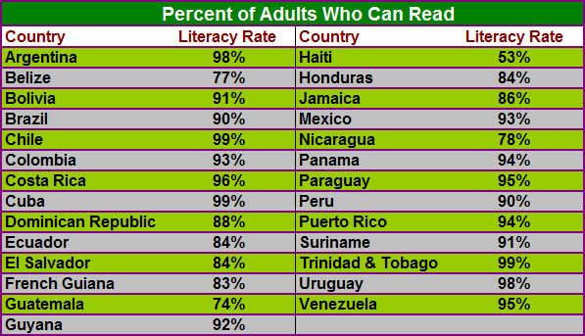
Latin America: Adult Literacy Levels
This chart shows basic adult literacy rates in several countries of Latin America. Basic literacy among adults is defined as having some skill in reading or writing. Countries such as Argentina, Cuba, and Uruguay have basic literacy rates above 95%, which is comparable to Canada and the United States. Most other Latin American nations have rates above 80%, though a few countries have much lower rates. Over the past 50 years literacy levels have improved greatly in the region, in large part as a function of urbanization. Higher literacy rates also reflect a relatively strong and well-funded primary education system. However, where the vast majority of a population has some reading skills, in many cases it is insufficient to allow people to take full advantage of opportunities in society. Basic literacy does not ensure that adults can, for example, understand a training manual, decipher a road map, or read a newspaper -- functional skills that could improve their standard of living.
Using the chart and your knowledge of Latin American history, answer the following questions:

WorldView Software: World Geography
GRAPH: Question 1
What percent of Chilean adults can read?
Question 2
Which two countries have the highest percentage of adults who are literate?
Question 3
What factors explain why an impoverished country such as Cuba has such a high literacy rate?

