GEOGRAPHY PORTION OF FINAL EXAM
Aborigines - original inhabitants of Australia
acid rain - a form of pollution in which chemicals come back to the earth as the form of rain, snow, or hail
Andean Countries (physical characteristics) – Coastal Plain, Highlands and Tropical Forests
Angel Falls – largest waterfall in the world
Apartheid – policy of strict racial segregation
Caribbean (3 island groups) – Greater Antilles, Lesser Antilles and The Bahamas
Capital Resource – the result of combining natural and human resources to create an economic system.

Caudillas – Latin American military dictator
Cays - Islands that are formed over thousands of years and made of coral
Central American natural hazards –
Commercial farming - raising crops and livestock to sell in markets

Continental drift – idea that continents slowly shift their position due to tectonic place movement
Countries that make up Great Britain - England, Scotland, and Wales
Culture – way of life that distinguishes a people, like government, language, religion, customs and beliefs
Dead Sea –
Demilitarized zone - strip of land on which troops or weapons are not permitted, Koreas
Desalination – process of removing salt from seawater
Deforestation –
Desertification – transformation of arable land into desert either naturally or with human help
dormant volcano – volcano not likely to erupt
Emigrant – a person who leaves their country in order to travel and live within another country
Ethnic roots found in Central America/Caribbean – African from slavery and Asians in search of work
Fertile Crescent –
Five (5) themes of Geography - place, region, human-environment interaction, location, movement
Gaucho - cowboy

Geothermal energy – describe the process - Heat from within the Earth. A hole drilled deep into the earth delivers hot water and steam. This steam turns turbines, creating energy. When the water cools down it is pumped back into the Earth to be recycled.
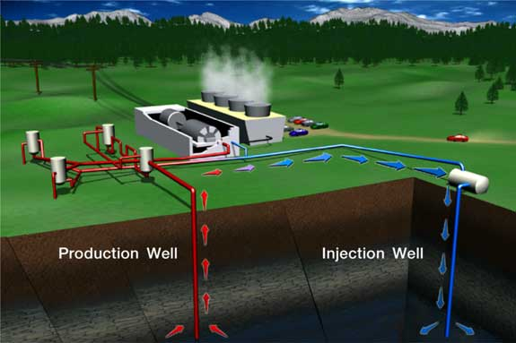
Glacier – slow moving mass of snow and ice
Global warming - Rise in Earth’s temperature
How many continents are there – 7
Human Resource - Produced by humans

hydroelectric power – electricity that is generated by moving water describe the process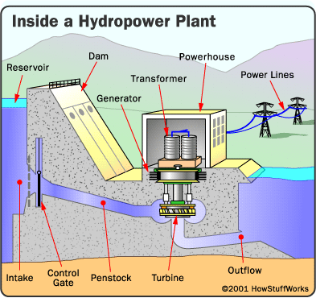
Industrial revolution – shift from human power to machine power, started in Western Europe
Latitude - how far north or south a place is from the Equator
Longitude - how far east or west a place is from the Prime Meridian
Major mountain range in South Asia – Himalaya Mountains
Major crop of Asia/South East Asia – rice
Mestizos – person with mix of European and Native American heritage
Mohandas Gandhi - Led India to independence through nonviolent resistance
Mt. Everest – tallest mountain in the world, found in the Himalayas
Mulattoes – person with mix of African and European ancestry
Natural Resource – found in nature
Nile River - lifeblood of Egypt, originating from Lake Victoria
nonrenewable resources – cannot be replaces after it is used up
Nuclear energy – describe the process - Nuclear reaction creates heat which is used to boil water into steam inside a reactor. The steam then turns huge turbines that drive generators that make electricity. The steam is then changed back into water and cooled down in a cooling tower. The water can then be used over and over again.
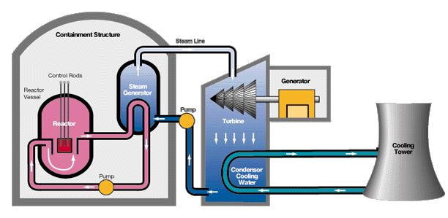
Nuclear waste - Environmental hazard produced by atomic power plants
Pacific Ring of Fire – A ring of volcanic mountains surrounding the Pacific Ocean
Peninsula of Peninsulas – Name for Europe because the continent is a peninsula with many peninsulas
“Plaza do las Tres Culturas” –
Poland (physical characteristics) –
Potato Famine of 1840’s –
Recycle - To make new products from old ones
Reincarnation - belief that the souls of humans/ animals goes through a series of births, deaths, & rebirths
renewable resources – a natural resource that continues to supply or replace itself as it is used
Sahara Desert – largest desert in Africa
Size of the Amazon River - carries more water than any other river in the world, largest in the world

Solar Energy – describe the process - Energy from the sum is collected through panels. The energy is either used or stored in batteries for further usage.
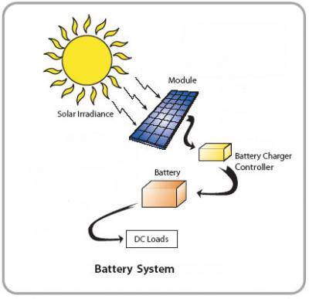
Steppe - temperate grassland found in Europe and Asia
Taiga – thinly scattered coniferous forests
temperate climate - An area that has warm and cool seasons
Terrace farming - Farming constructed in hilly regions, used to increase the amount of arable land
Three forms of erosion - Wind, water, and glaciers are three forms of erosion
Tsunami – a tidal wave caused by an underwater earthquake
Tundra – region with cool or cold temperatures and only specialized plants can grow there
Types of Monsoons – wet - summer monsoon, dry - winter monsoon
Urbanization –the growth of city population
What Countries border the United States – Canada and Mexico
What country was set up in the Middle East for the displaced Jewish people - Israel
What is the world’s biggest country - Russia
Who are the people who follow the Jewish religion - Jewish
Why do only small plants grow on the forest floor of the tropical rain forests – Lack of sunlight due to the thick canopy of trees above
Why is hunger a problem still in South Asia – lack of arable land and an increasingly large population
Why is the Aral Sea drying up? Water is being drained away for irrigation
Formation of Himalaya Mountains compared to Japanese Islands – Him. – Tectonic plate collision Jap. – Volcanic activity

Pennsylvania History Final Exam Study Guide
Be able to Identify or answer the following terms/questions:
What are the 2 types of coal in Pennsylvania –
Anthracite (hard) bituminous (soft)
5 geographic regions of PA (know on map)- 1 Atlantic coastal plain 2 Piedmont 3 Ridge and Valley 4 Allegheny Plateau 5 Erie Plain
Age of Enlightenment – in the 1500’s when Europeans tried new things
Allegheny Portage – unusual railroads built over the mountains, areas where canals could not go
Andrew Carnegie – man responsible for the steel growth in PA
Ben Franklin (how did he help during American Revolution)- got French to send money and soldiers to help fight British during revolution
Capital of Pennsylvania – Harrisburg
Charles Duryea – successfully applied the gasoline engine to a four-wheeled vehicle in 1893
Civil War – a dispute between citizens of the same country
Clan – small Indian village named after an animal
County seat – place where county government is headquartered
Depression – a slow-down in business activity
Economics – the study of productions, distribution, and consumption of goods and services
Edwin Drake – created the world’s first oil well in PA

Emigrant – a person who leaves their country in order to travel and live within another country
Ferryboats – allowed wagons to cross rivers in the 1800’s by floating the wagon on a large raft
First oil well – area of Titusville, called Oil Creek, where first oil well was drilled
Gettysburg – site of one of the bloodiest battles of the Civil War
Gettysburg Address – speech given by Abraham Lincoln to dedicate cemetery
Gifford Pinchot – man responsible for settling up the National Forest system and was governor of PA for two terms
Glass industry (what, where, why)- glass industry was launched in Pittsburgh because of its abundance of sand and cheap fuels
James Buchanan – only president from PA
Johnstown – site of a tragic flood in 1889 that saw the first disaster relief center set up in the U.S.
Longhouse – Iroquois dwelling that a dozen families lived in
Loyalists – people who did not want freedom from England during the Revolutionary War
Matthias Baldwin – built the first steam train in Pennsylvania
Meaning of word Pennsylvania – Penn’s Woods
Men in Iroquois tribes (role)- when a man became to old to care for himself, he was returned to his mothers clan
Number of counties in Pennsylvania – 67 counties
Protestant reformation – time when the Catholic church was protested
Role of Native American men – warrior and hunter
States that border Pennsylvania – look them up
Toll Road – stone surfaced road, built around 1800, in PA, charged travelers a sum of money they they paid at a pike, or a gate within the road
Walking Purchase – example of a dishonest land purchase between European settlers and Native Americans, here in Pennsylvania
Underground Railroad – a network established that helped slaves escape from the South to gain their freedom in the northern states
Weaknesses of the Articles of confederation – No central government, No power to make people go to war, no way to make people obey the law, no way to levy or collect taxes, no mechanism for solving arguments among the states, no way to regulate trade between states
What is needed before economic growth and development? Good transportation system is needed
Why/Where,When was Washington sent to tell the French in 1753 – sent to Fort LeBeouf, by the Governor of Virginia, to ask them to leave the area
William Penn and the Native Americans relationship – fought hard to be fair and to create harmony with the Delaware Indian tribe
Immigrant - People entering "IN" our country from another
Conestoga Wagon - sturdy wagon built in Lancaster, used to carry supplier for the pioneers
Drakes Well - world's first oil well was drilled in 1859 in Titusville, Pennsylvania, Oil Creek
What countries wanted control of the Ohio valley for the fur trade – Europe and France
Oil Creek – place where first oil well was drilled in 1859

