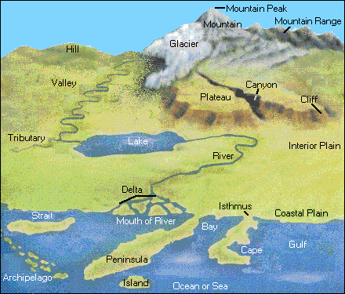
Geographical Features
This diagram provides an artist's view of some topographical features of the surface of the earth. In real life, these features may look considerably different, as you know, because you have probably seen some of these. The features of the earth's surface vary in several ways, including their location, their elevation, and their ruggedness. However, there are some basic definitions about topographical features that remain consistent:

- Both a coastal plain and an interior plain are flat, but a coastal plain is located near a body of water, while an interior plain is not.

- A hill is lower in elevation than a mountain. A mountain is usually more conical in shape than a hill.

- A glacier is made from ice. Some glaciers are formed on mountains because of the higher elevations and lower temperatures.

- The top of a plateau is flat, while its sides are steep.

- A delta can be formed when a river flows into a standing body of water, such as a gulf or ocean, and deposits sediment. A delta is found at the mouth of a river.

- The difference between a peninsula and an island is that an island is surrounded on all sides by water, while a peninsula is surrounded on only three sides by water.

- An archipelago is a group of islands.

- An isthmus is a narrow piece of land joining two larger pieces of land.

- A river flows through its banks. A tributary is a stream or river that flows into another, usually larger, river.

- A lake is an inland body of fresh water.

- A bay is a part of an ocean that is partially enclosed by land, while a harbor is also an enclosed part of an ocean, but is smaller.

Using the image, answer the following questions:

WorldView Software: World Geography
ART: Question 1
Do any of the topographical features in the above diagram match those found in the area where you live?

Question 2
How do you think topographical features affect patterns of human settlement?

Question 3
How do you think topographical features affect other activities, such as industry, tourism, and trade?

Question 4
Describe the most prominent topographical feature in your area. Then draw a picture of it.

