NAME: _______________________________________________ Pd: ___________
GEOGRAPHY PORTION OF FINAL EXAM (Be able to Identify or answer the following terms/questions)

Aborigines -

acid rain –

Andean Countries (physical characteristics) -

Angel Falls –

Apartheid –

Caribbean (3 island groups) -

Caudillas –

Cays -

Central American climate hazards -

Commercial farming -

Continental drift –

Countries that make up Great Britain -

Culture –

Dead Sea -

Demilitarized zone -

Desalination –

Deforestation –

Desertification –

dormant volcano –

Emigrant –

Ethnic roots found in Central America/Caribbean –

Fertile Crescent -

Five (5) themes of Geography -

Gaucho –

Geothermal energy - describe the process
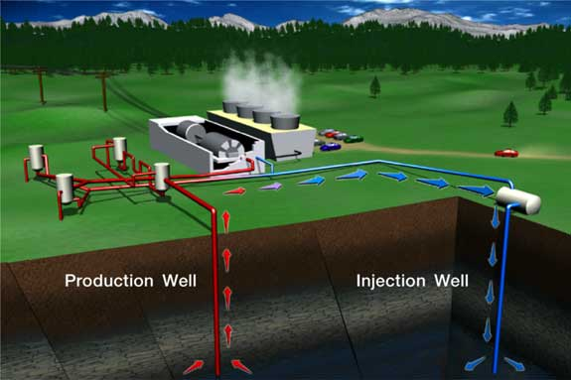
Glacier –

Global warming -

How many continents are there -

Human Resources

Industrial revolution –

hydroelectric power – describe the process
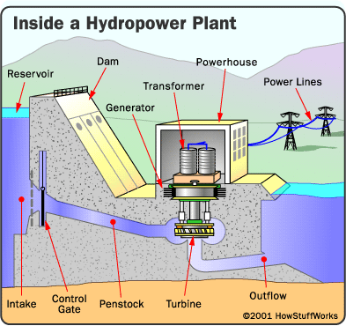

Latitude –

Longitude -

Major mountain range in South Asia –

Major crop of Asia/South East Asia -

Mestizos –

Mohandas Gandhi -

Mt. Everest -

Mulattoes –

Natural Resources –

Nile River -

nonrenewable resources –

Nuclear energy – describe the process
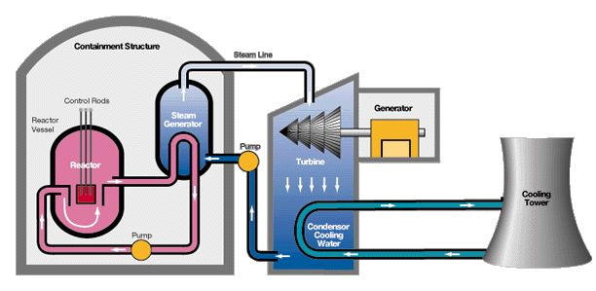

Nuclear waste –

Pacific Ring of Fire –

Peninsula of peninsulas -

“Plaza de las Tres Culturas” –

Poland (physical characteristics) –

Potato Famine of the 1840s -

Recycle -

Reincarnation -

renewable resources –

Sahara Desert –

Size of the Amazon River –

Solar Energy - describe the process
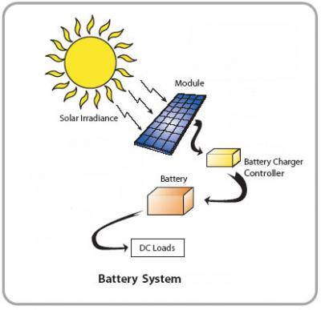

Steppe -

Taiga –

temperate climate -

Terrace farming -

Three forms of erosion -

Tsunami -

Tundra –

Types of Monsoons –

Urbanization –

What Countries border the United States –

What country was set up in the Middle East for the displaced Jewish people -

What is the world’s biggest country -

Who are the people who follow the Jewish religion -

Why do only small plants grow on the forest floor of the tropical rain forests –

Why is hunger a problem still in South Asia –

Why is the Aral Sea drying up?

Formation of Himalaya Mountains compared to Japanese Islands –

Pennsylvania History Final Exam Study Guide: (Be able to Identify or answer the following terms/questions)

What are the 2 types of coal in Pennsylvania –

5 geographic regions of PA (know on map)-

Age of Enlightenment –

Allegheny Portage –

Andrew Carnegie –

Ben Franklin (how did he help during American Revolution)-

Capital of Pennsylvania –

Charles Duryea –

Civil War –

Clan –

County seat –

Depression –

Economics –

Edwin Drake –

Emigrant –

Ferryboats –

First oil well –

Gettysburg –

Gettysburg Address –

Gifford Pinchot –

Glass industry (what, where, why)-

James Buchanan –

Johnstown –

Longhouse –

Loyalists –

Matthias Baldwin –

Meaning of word Pennsylvania –

Men in Iroquois tribes (role)-

Number of counties in Pennsylvania –

Protestant reformation –

Role of Native American men –

States that border Pennsylvania –

Toll Road –

Walking Purchase –

Underground Railroad –

Weaknesses of the Articles of confederation –

What is needed before economic growth and development?

Why/Where,When was Washington sent to tell the French in 1753 –

William Penn and the Native Americans relationship –

Immigrant -

Conestoga Wagon -

Drakes Well -

What countries wanted control of the Ohio valley for the fur trade –

Oil Creek –

