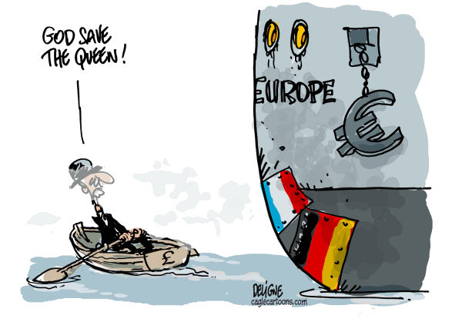

## Your test is now in your hands. Imagine you are in a restaurant and you are choosing your meal. Below describes what you can “order” for your test grade. Choose wisely and aim high! Additional research into the areas will help you get full points. (100 Point Maximum - but you can/should do more to ensure the highest grade possible). Use notes, PowerPoints and Internet.

## All answers can be typed, handwritten or verbally recorded if possible.

Copies of rubrics/directions can be found in the classroom and on the Europe web page.

**COMPLETE SENTENCES ARE MANDATORY ON THE TEST**

# **Café de Classroom** – Europe Test Menu

Life on the Northern European Plains…………………………………………….*(up to 20 points)*

For this option you will put yourself in the place of a farmer found on the Northern European Plain (you pick the location). You need to tell what the plains are like (type of soil, landscape), how you plant your crops, how you water the crops, and how you harvest the crops. You will also need to discuss how you would get your crops from your fields and out to the rest of the world – tell what route you would choose.

Mapping Madness…………………………………………….…….…………………. *(up to 20 points)*

You will need to get a blank map from the classroom and make it look like a physical map of Europe. You need to fill it with the following information:

* Physical/Geographic features including mountains, rivers, plains, bodies of water (use colors)

“Mini Travel Journal” …………………..……………….…………………….*(up to 40 points)*

You will need to do a travel journal that includes 1 country from Western Europe and 1 country from Eastern Europe – **2 countries total**. You CANNOT use a country that you already used for a travel journal. The guideline are the same as the last travel journal. Get a copy of the rough draft (if needed) and a rubric. The rubric must be turned in with the final version.

European Experiences……………………………………….………………………. (up to 40 points)

For this option you will act as a travel agent and create a poster to be used to persuade and educate people to want to travel to the country you pick. You will include information about the 5 Themes of Geography as well as pictures. Get a copy of the rubric from the classroom or web page if you plan on ordering this option.

Mountain Madness………….……………………….……………………………….*(up to 10 points)*

For this option you will need to tell compare/contrast the Alps and the Apennines. In addition you tell similarities and differences you **MUST** include the following information for both mountains: location, elevation, size, plant life, animals, etc.

Commie to Cold War and Beyond…………………….………….………………….*(up to 10 points)*

In this option you will walk an Eastern European country from falling under the control of the communist Soviet Union after WWII through the Cold War and finishing with problems they faced after the collapse of Communism and when the country became independent. You need to talk about the problems they faced along the way as well as the problems they ran into after independence.

An “Artistic” Approach……………………….……………………………………. *(up to 10 points)*

Showcase your talents by playing, singing, dancing, drawing, etc. You need to perform between 30-60 seconds of a song/dance that comes from Europe. If you perform for a small group setting you will get 8 points. If you perform for the class it will be worth 10 points.

England vs. Scotland………………………………………….……………………. *(up to 10 points)*

You will need to compare/contrast the 3 areas of England with the 3 regions of Scotland. This means similarities and differences. You must use all 6 regions in your answer.