WorldView Software: World Geography
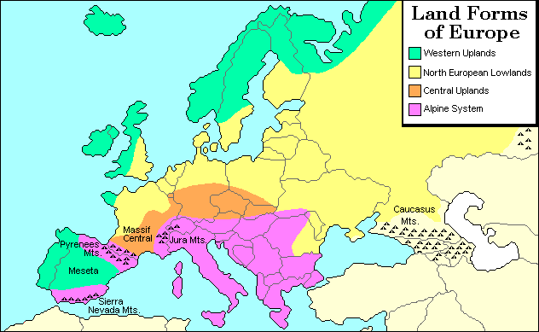
Land Forms of Europe
This map shows the four major landforms of Europe. They are the North European Lowlands, Western Uplands, Central Uplands, and the Alpine System. The North European Lowlands, stretching from the Atlantic Ocean across northern Europe, is a belt of plains, low hills, and river valleys. It is also called the North European Plain. The Western Uplands are old in geologic terms and are therefore low, rounded mountains and plateaus. They stretch from the Iberian Peninsula, to Brittany in France, to the western British Isles, then north of the North European Lowland through northern Scandinavia, Finland, and northwest Russia. The third topographic region, the Central Uplands, as its name implies, runs through Central Europe. It too consists of mountains and plateaus. The Alpine System is the youngest region geologically and therefore is made of tall mountains which are jagged and steep. The Alpine system extends from the northern and southern parts of the Iberian Peninsula, missing part of southern France, but dominating through southern Europe. The map shows several mountain ranges. The Ural Mountains extend about 1,500 miles from the Caspian Sea to the Russian Arctic. They are considered the traditional boundary between Europe and Asia. The Caucasus Mountains are geologically younger and much taller. They also serve as a divider between Europe to the north and west and Asia to the south and east. These topographic regions and mountains have been used in a variety of ways by people over thousands of years. The mountains and valleys have affected atmospheric behavior, thus contributing to climate variation. The physical geography has helped and hindered human migrations; it has provided resources on which much of Europe built a rich economy; and it has contributed to extreme national rivalries, sometimes leading to bloodshed and war. However, it was not the physical geography alone that was responsible for either progress or tragedy. It was the way people chose to use their natural environments.
MAP: Question 1
What does this map show?
Question 2
What are the four major landforms of Europe?

Question 3
Which landform is geologically the youngest? How can you tell?

Question 4
What economic activities developed in the Central Uplands? Why? In the Western Uplands? Why?

Question 5
Why are the Ural Mountains lower than the Caucasus Mountains?

