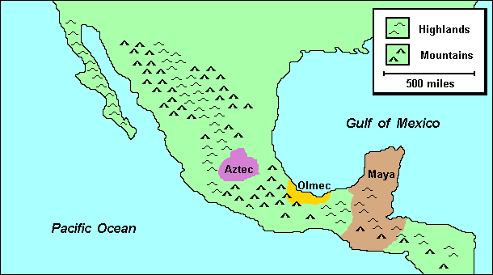
Cultures of Mexico and Central America
When Europeans arrived in Mesoamerica (Mexico and Central America) in the 1500s, they encountered a region with a tradition of 3,000 years of civilization. The "mother of Mexican civilization," the Olmec culture flourished near the Gulf of Mexico between 1500 B.C.E. and 400 B.C.E., producing impressive stone carvings and an early calendar. Between 400 B.C.E. and 900 C.E., the Mayan peoples developed what was perhaps the most sophisticated of the pre-Columbian cultures. Centered in the Yucatan Peninsula in present-day Mexico and Guatemala, the Mayans excelled in astronomy, mathematics, and writing. They also created the most accurate calendar in the world at the time. By 1100 C.E., for reasons that remain uncertain, the Mayan empire disappeared. The Aztecs, based in Central Mexico, used terror and military violence to rule an empire that lasted from 1200 C.E. until they were conquered by the Spanish in 1521 C.E. The Aztecs were not cultural innovators, but inherited a well-developed civilization with compulsory primary schooling, sophisticated medical knowledge, and an impressive artistic tradition. Their capital Tenochtitlan, the location of present-day Mexico City, was one of the largest cities in the world at the time.
Using the map and your knowledge of Latin American geography, answer the following questions:

WorldView Software: World Geography
MAP: Question 1
Which of the three civilizations had the largest territorial extension?
Question 2
Which of the three civilizations was the most advanced?
Question 3
In what ways did Mexico's pre-Columbian Indian heritage shape its culture today?

