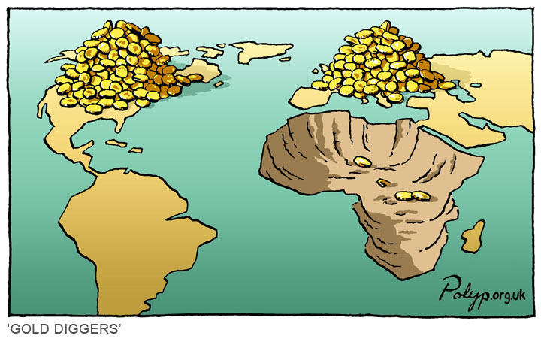

## Your test is now in your hands. Imagine you are in a restaurant and you are choosing your meal. Below describes what you can “order” for your test grade. Choose wisely and aim high! Additional research into the areas will help you get full points. (100 Point Maximum - but you can/should do more to ensure the highest grade possible). Use notes, PowerPoints and Internet.

## All answers can be typed, handwritten or verbally recorded if possible.

Copies of rubrics/directions can be found in the classroom and on the Europe web page.

**COMPLETE SENTENCES ARE MANDATORY ON THE TEST**

# **Café de Classroom** – Africa Test Menu

HEI on the Banks of the Nile River ……………….……………………………….*(up to 20 points)*

For this option you will put yourself in the place of a person living on the banks of the Nile River back in ancient Egypt. You need to talk about how you lived, how the Nile River changed your life year after year, how the Nile River helped you year after year and finish up imagining that you move forward in history and the Nile River is now has a dam blocking it. Talk about how the dam helped and hurt your ancestors.

Mapping Madness X’s 2…………………………………….…….…………………. *(up to 20 points)*

You will need to get a blank map from the classroom and make both a physical map of Africa and a separate climate map of Africa. You need to fill it with the following information:

* Physical/Geographic features including mountains, rivers, plains, bodies of water (use colors)

“Mini Travel Journal” …………………..……………….…………………….*(up to 40 points)*

You will need to do a travel journal that includes 2 countries from Africa – **2 countries**. The guideline are the same as the last travel journal. Get a copy of the rough draft (if needed) and a rubric. The rubric must be turned in with the final version.

Geographic Journey……………………………………….……………………………. (up to 40 points)

For this option you travel across the 5 Geographic Regions of Africa (North Africa, West Africa, South Africa, East Africa, and Central Africa). You will need to use a minimum of 3 complete sentences for each of these regions. Feel free to use materials from all PowerPoints to get your information. A sentence stating the region does not count towards your points.

Ma vs Pa………….…….……….………………………….………………………….*(up to 10 points)*

For this option you will need to tell compare/contrast the matrilineal and patrilineal societies of Africa. You must rewrite the information in your own words and it must not look like what is found in the notes and/or PowerPoints.

Triangular Slave Trade…………………….…………….…….….………………….*(up to 10 points)*

In this option you will explain the origin of the use of slaves from Africa. You need to explain **who** was involved, **what** took place, **where** it happened, **when** did it happen, **why** did they need the slaves and **how** did the end of slavery come about to be.

An “Artistic” Approach……………………….……………………………………. *(up to 10 points)*

Showcase your talents by playing, singing, dancing, drawing, etc. You need to perform between 30-60 seconds of a song/dance that comes from Africa. If you perform for a small group setting you will get 8 points. If you perform for the class it will be worth up to 10 points.

Gold – Salt Trade…….………………………………………….……………………. *(up to 15 points)*

For this answer you will need to tell a story. You are taking the role of a merchant about to cross the Sahara Desert. You need to explain why you need salt and why it is so important as well as what you do to get it.