Two Ways to Count to Ten
~ An African Folktale from Liberia~
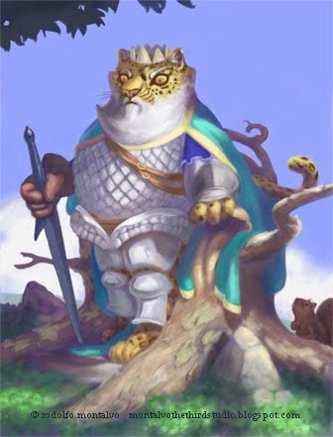

A long time ago, deep in the forests of Liberia, King Leopard began to think about the future. He thought, "I'm getting old and one day when I get real old, I'm going to get sick and die". Now a wise king would not wait until he was old to pick a successor, someone who could take his place as king after he died. No, a wise king would pick his successor while still young and healthy. But how could King Leopard choose when he loved all the members of the animal kingdom the same? How could he choose one over the other?
King Leopard sat beneath a tree and started to think. After a while, he came up with a plan. He summoned his messengers and sent them out into the forests of Liberia. He told them to ask all of the animals of the animal kingdom to come to his palace. He was going to throw a big party and at this party, he was going to make an important announcement. So, away the messengers ran, to all four corners of the forest.
On the night of the party, the forest came alive with excitement. It seemed like all the animals were at King Leopard's palace. They sang and they danced and had a great time. Then, after the moon had risen above the trees, King Leopard came and stood in the middle of the clearing. The animals looked up and saw the king. They stopped their singing and dancing and showed their respect for the king by listening quietly as he began to speak.
"I've been thinking that it's time for me to pick a successor. But because I love all of you equally, I can't decide who among you is most worthy. I have decided to let a contest decide for me."
King Leopard walked a short way into the trees and came back carrying a spear. He said, "The first one among you who can take this spear and throw it into the sky and count all the way to ten before it touches the ground will be my successor."
As soon as King Leopard finished making this announcement, the animals began to talk excitedly among themselves. But suddenly they were disturbed by a loud noise from the rear. The animals looked around to see what was going on, and had to quickly move out of the way for Elephant was stomping through the crowd to the front. Elephant was going to participate in the contest. As he came forward, he said "Move out of my way. Move out of my way. I'm gonna be king. I'm gonna be king. I'm the biggest, I oughta be king."
"All right," said King Leopard "you can be the first. But before you throw the spear you must first do a dance of victory."
Elephant lumbered around the clearing, stomping his legs and trumpeting with his trunk. After a few minutes, Elephant took the spear and curled it up in his long trunk. Then he thrust his head way back and threw the spear into the sky.
"One! Two! Three!" Elephant cried.
The spear hit the ground on the count of four.
Elephant did not win the contest. He was so angry that he started stomping and blowing his trumpet. King Leopard told him "Elephant, you only get one chance and you've had your chance." And so Elephant had to leave.
After Elephant left, the animals started to talk excitedly amongst themselves again, but as before, they were disturbed by a loud noise coming from the rear.
Boar came charging through the crowd saying "Get outa my way. Get outa my way. I'm gonna be king. I'm gonna be king. I've got the biggest muscles, I oughta be king."
"All right, alight" said King Leopard. "You know the rules. Before you throw the spear, you must first do a dance of victory."
And so the boar did his dance of victory. He dropped to the ground and lifted his entire weight on one foot, then he jumped up and down and all around.
Finally, with his sharp claws, Boar began to dig a hole in the ground. He made the hole deeper and deeper until all you could see was the top of his head. Then he took the spear, clenched it in his teeth, threw his head back and cast the spear into the sky.
"One! Two! Three! Four! Five!" he shouted.
The spear hit the ground on the count of six.
Boar did not win the contest. He was so angry that he started blowing and fuming and tossing clods of dirt into the air. King Leopard told him "Boar, you only get one chance and you've had your chance." And so Boar had to leave.
After that, the animals started to express. They said things like, "Goodness! This contest is hard. Elephant couldn't do it, and he's real big. Boar couldn't do it either, and he's real strong. I don't think any body's gonna win this contest!"
Right about then, they heard another sound coming from the rear and when the animals looked around, they couldn't believe their eyes. The saw Monkey coming through the crowd. As Monkey came forward, he chanted "I can do it. I can do it. I know I can do it. I can do it, nothing to it. I can do it. I know I can do it."
"All right" said Leopard, "Go ahead with your dance of victory."
"Sure thing king," said Monkey, "I love to dance. Stand back and give me room."
And so Monkey did his dance of victory. He leapt up and down and all around. He grabbed up a branch from the ground and shook it and danced around and around.
"All right Monkey", said Leopard. "Here's your spear."
Monkey took the spear and he backed way up. Then he pulled his arm back, charged forward, leapt into the air and threw the spear into the sky.
"One! Two! Three! Four! Five! Six! Seven!" cried Monkey.
The spear hit the ground on the count of eight. Monkey did not win the contest. Monkey was upset. He was so angry that he started turning flips, complaining and making all sorts of excuses and begging for a second chance. But King Leopard told him "No Monkey, you only get one chance". And so Monkey had to leave.
After that happened, the animals really began to doubt that any animal could win the contest. They said things like "My goodness. This contest is so hard! I thought our king was wise and smart, but maybe he's finally decided to use his smarts against us! Maybe he knows that nobody can take that spear and throw it into the sky and count all the way to ten before it hits the ground! Why King Leopard might be making fools out of us all! I for one am not going to stand around here and be made a fool of." And so some of the animals turned and started to head for home, but as they were leaving, they heard yet another sound coming from the rear.
When they animals looked around this time, they saw an unbelievable sight. They saw a tiny, tiny antelope coming through the crowd. As the antelope came forward, he said, "Wait, wait. Let me try. Let me try. I can do it. I can do it. Let me try."
When the animals heard that, they all burst out laughing. Elephant rumbled up to Antelope and said "What do you mean, you can do it? Why if I can't do it, you certainly can't. Go home you little runt."
At this, the animals really started to laugh. King Leopard jumped up and shouted angrily, "Stop it! Stop it! I will not have you making fun of antelope like that! Who is to say that small animals can't do things that big animals can do? If antelope wants to have a chance, he's going to be given the same chance that all the other animals had. So stand back and let Antelope do his dance of victory."
On that long ago night, deep in the forests of Liberia little antelope did dance, but his dance was real different from the dances of the other animals. Antelope slowly moved around in a circle, extending his legs gracefully while lifting his head towards the sky almost as if he were thanking the heavens for being alive. Then Antelope turned towards the animals and it was as if he was saying that he loved all the animals and was happy and proud to be part of such a beautiful and diverse animal kingdom. Finally, Antelope turned and looked towards the king and it was as if he was saying that he loved the king, who was so wise and yet so kind. Antelope bowed down to his king, turned and took the spear in his mouth. He backed up, clenched the spear hard between his teeth and with every ounce of strength in his tiny body he started running. When he reached the center of the clearing, he leapt upwards and released the spear.
"Five plus five equals ten" he shouted.
All the animals were quiet. "What is this?" Asked Elephant. "Five plus five equals ten?" Monkey scratched his head in confusion.
King Leopard came forward and explained everything. He said "Yes Antelope! Yes, you're absolutely right. Five plus five does equal ten and so does three plus seven and lots of other combinations! Five plus five is another way to get to ten! This contest was not a contest to find out who was the biggest or who was the strongest. It was a contest to see who is the smartest!"
And that's how Antelope, the smallest animal of the forest became king after Leopard stepped down. Not because he was the biggest or the strongest, but because he was the smartest.

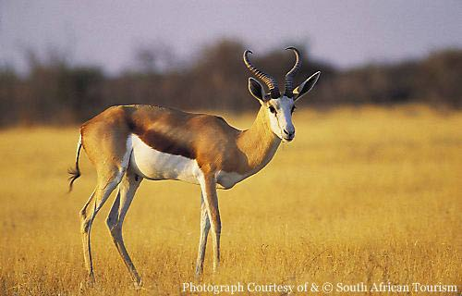
Just call me “KING!”

